**Number Systems Used In Computers**

Complete the following table:

|  |  |  |  |
| --- | --- | --- | --- |
| **Number System** | **Number Base** | **Digits Used** | **Purpose** |
| Decimal | Base 10 | 0 to 9 | Used for communicating with human users |
| Binary |  |  |  |
| Octal |  |  |  |
| Hexadecimal |  |  |  |

**Decimal vs. Binary System**

Write down the definition of a **Bit** in computer terminology:

Complete the following table:

|  |  |  |
| --- | --- | --- |
|  | **Decimal System** | **Binary System** |
| Uses Digits |  |  |
| Addition Examples |  |  |
| Powers of 10 |  |  |
| Evaluate 111 |  |  |

**Powers of 2**

|  |  |  |  |  |
| --- | --- | --- | --- | --- |
| **Power  of 2** | **Decimal Value** | **Integer Range** | **Number  of Bits** | **Computer Binary** |
| 21 | 2 | 0 - 1 | 1 | 0001 |
| 22 | 4 | 0 - 3 | 2 | 0011 |
| 23 |  |  |  | 0111 |
| 24 |  |  |  | 1111 |
| 25 |  |  |  | 0001 1111 |
| 26 |  |  |  | 0011 1111 |
| 27 |  |  |  | 0111 1111 |
| 28 | 256 | 0 - 255 | 8 | 1111 1111 |
| 29 |  |  |  | 0001 1111 1111 |
| 210 |  |  |  | 0011 1111 1111 |
| 211 |  |  |  | 0111 1111 1111 |
| 212 |  |  |  | 1111 1111 1111 |
| 213 |  |  |  | 0001 1111 1111 1111 |
| 214 |  |  |  | 0011 1111 1111 1111 |
| 215 |  |  |  | 0111 1111 1111 1111 |
| 216 | 65,536 | 0 – 65,535 | 16 | 1111 1111 1111 1111 |

**Conversions**

Convert the following binary numbers to decimal:

11 binary =

101 binary =

1010 binary =

Convert the following decimal numbers to binary:

6 decimal =

13 decimal =

**Binary Addition**

Add the following binary numbers. (verify your answers using decimal)

|  |  |  |  |  |  |  |  |  |  |  |  |  |  |
| --- | --- | --- | --- | --- | --- | --- | --- | --- | --- | --- | --- | --- | --- |
| |  |  | | --- | --- | | **0101** | **(decimal 5)** | | **+ 0010** | **(decimal 2)** | |  |  | | |  |  | | --- | --- | | **0101** | **(decimal 5)** | | **+ 1010** | **(decimal 10)** | |  |  | |
| |  |  | | --- | --- | | **0011** | **(decimal 3)** | | **+ 0010** | **(decimal 2)** | |  |  | | |  |  | | --- | --- | | **0110** | **(decimal 6)** | | **+ 0011** | **(decimal 3)** | |  |  | |

**Prefixes**

* Kilo (K) means __________________ Multiply by x______________
* Mega (M) means _________________ Multiply by x______________

* Giga (G) means __________________ Multiply by x______________
* Tera (T) means __________________ Multiply by x______________

**Examples**

1. 64 Kbps (Kilo-bits per seconds) = ___________________ bps (bits per second)
2. 256 Giga-bytes = _________________________________ bytes
3. 256 Giga-bytes = _________________________________ bits

**Computer Memory Structures**

|  |  |  |  |
| --- | --- | --- | --- |
| **Structure** | **Number of Bits** | **Largest Value** | **Used For...** |
| Bit |  |  |  |
| Byte |  |  |  |
| Word |  |  |  |
| Short Integer |  |  |  |
| Double Word |  |  |  |
| Long Integer |  |  |  |
| Memory Address |  |  |  |

**Memory Organization**

Bit (Binary Digit)

* One bit can have a value of ________ or _________
* Or a Boolean logic value of ________ or _________

|  |  |  |  |  |  |  |  |  |  |  |  |  |  |  |  |  |  |  |  |
| --- | --- | --- | --- | --- | --- | --- | --- | --- | --- | --- | --- | --- | --- | --- | --- | --- | --- | --- | --- |
| |  |  |  |  | | --- | --- | --- | --- | | 0 | 0 | 0 | 0 | | |  |  |  |  | | --- | --- | --- | --- | | 0 | 0 | 0 | 0 | | |  |  |  |  | | --- | --- | --- | --- | | 0 | 0 | 0 | 0 | | |  |  |  |  | | --- | --- | --- | --- | | 0 | 0 | 0 | 0 | |

Byte (8 bits)

* One byte has a size of ________ bits
* A byte has an unsigned integer value range from 0 to _________

|  |  |  |  |  |  |  |  |  |  |  |  |  |  |  |  |  |  |  |  |
| --- | --- | --- | --- | --- | --- | --- | --- | --- | --- | --- | --- | --- | --- | --- | --- | --- | --- | --- | --- |
| |  |  |  |  | | --- | --- | --- | --- | | 0 | 0 | 0 | 0 | | |  |  |  |  | | --- | --- | --- | --- | | 0 | 0 | 0 | 0 | | |  |  |  |  | | --- | --- | --- | --- | | 0 | 0 | 0 | 0 | | |  |  |  |  | | --- | --- | --- | --- | | 0 | 0 | 0 | 0 | |

Word (2 bytes or 16 bits)

* One word has a size of ________ bits
* One word has a size of ________ bytes
* A byte has an unsigned integer value range from 0 to _________

|  |  |  |  |  |  |  |  |  |  |  |  |  |  |  |  |  |  |  |  |
| --- | --- | --- | --- | --- | --- | --- | --- | --- | --- | --- | --- | --- | --- | --- | --- | --- | --- | --- | --- |
| |  |  |  |  | | --- | --- | --- | --- | | 0 | 0 | 0 | 0 | | |  |  |  |  | | --- | --- | --- | --- | | 0 | 0 | 0 | 0 | | |  |  |  |  | | --- | --- | --- | --- | | 0 | 0 | 0 | 0 | | |  |  |  |  | | --- | --- | --- | --- | | 0 | 0 | 0 | 0 | |
|  | |  | |

Long or Double Word (4 bytes or 32 bits)

* One Long word has a size of ________ words
* A Long word has an unsigned integer value range from 0 to _________

|  |  |  |  |  |  |  |  |  |  |  |  |  |  |  |  |  |  |  |  |
| --- | --- | --- | --- | --- | --- | --- | --- | --- | --- | --- | --- | --- | --- | --- | --- | --- | --- | --- | --- |
| |  |  |  |  | | --- | --- | --- | --- | | 0 | 0 | 0 | 0 | | |  |  |  |  | | --- | --- | --- | --- | | 0 | 0 | 0 | 0 | | |  |  |  |  | | --- | --- | --- | --- | | 0 | 0 | 0 | 0 | | |  |  |  |  | | --- | --- | --- | --- | | 0 | 0 | 0 | 0 | |
|  | |  | |
| |  |  |  |  | | --- | --- | --- | --- | | 0 | 0 | 0 | 0 | | |  |  |  |  | | --- | --- | --- | --- | | 0 | 0 | 0 | 0 | | |  |  |  |  | | --- | --- | --- | --- | | 0 | 0 | 0 | 0 | | |  |  |  |  | | --- | --- | --- | --- | | 0 | 0 | 0 | 0 | |
|  | |  | |

**Questions**

1. What is the smallest memory object that can represent a character of information?
   1. Think… How many upper case letters in the alphabet (A to Z)?

26

* 1. Think… How many lower case letters in the alphabet (a to z)?

26

* 1. Think… How many number digits (0 to 9)?

10

* 1. Think… How many punctuation marks?

14

* 1. Add them all up

76

1. Research the ASCII characters set. What is it and how is it related to computer memory?  
   The most widely accepted code is called the American Standard code for Information interchange which associates an integer value for each symbol in the character set such as letters, digits, punctuation marks and more it is related to computer memory because is uses one byte of memory per character while the original version of ASCII used only 7 of the 8 bit available, which allowed 128 different characters to be represented using binary codes 0000000 to 1111111
2. How are strings of characters (Google “String”) represented in computer memory?

If text is stored on a computer, it is usually stored as string or text string which is a series of ASCII characters and each one is stored in one byte. A computer stores computer strings as 53, 74, 72 and more

1. How are negative integers represented in computer memory? (Include a diagram)

A integers is a number with no fractional pare which means it can be positive, negative on a zero, in ordinary usage one uses a minus sign to designate a negative number however a computer can only store information in bits which can only be in binary code (zeros or ones)   
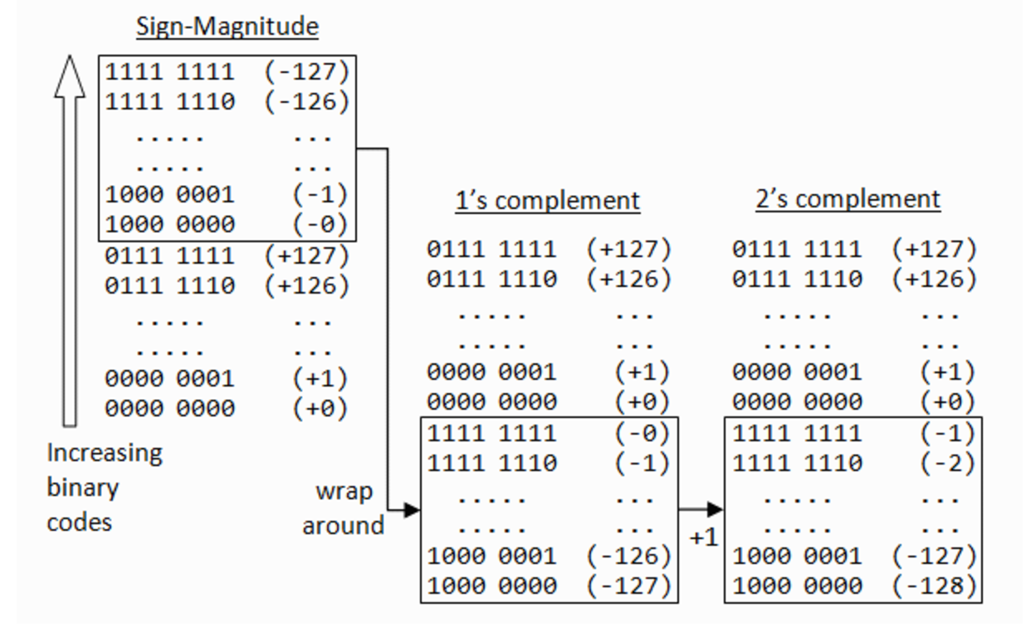

1. How are decimal numbers (Google “Floating Point”) represented in computer memory? (Include a diagram)  
   Floating point or single-precision floating point format is a computer number format usually occupying 32 bits in computer memory. Floating point represents a wide dynamic range of numeric values by using a floating radix point. 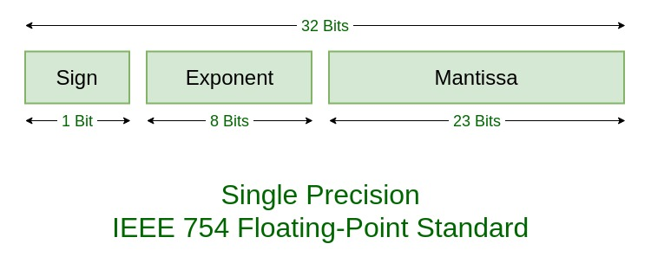
2. A Pixel is computer memory structure used to store image information. How is a Pixel represented in memory? (Include a diagram).

A pixel is the smallest element in an image, holding antiquated values that represent the brightest of a given colour, typically the pixels are stored in computer memory as a raster map or a two dimensional array of small integers